**E-Commerce Application**

**(Using Spring Boot as Backend)**

**Abstract:**

* The E-commerce Application is built using java and Spring Boot, with scalability, and ease of maintenance. The backend uses Spring Data JPA to interact with a MYSQL database, making it easy to manage and store. Providing a comprehensive solution for managing users, products, addresses, and orders. This Spring-based E-commerce allows you to manage users, products, addresses, and orders for an online store.

**Technologies:**

* Java Development Kit (JDK)
* Languages & Frameworks : Java, Spring Boot
* Database : MYSQL
* For testing ApI’s : Postman
* Maven (for project build management)

**Database Design:**

CREATE DATABASE ecommerce;

USE ecommerce;

show tables;

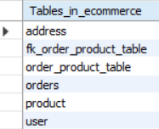

**ER Diagram:**

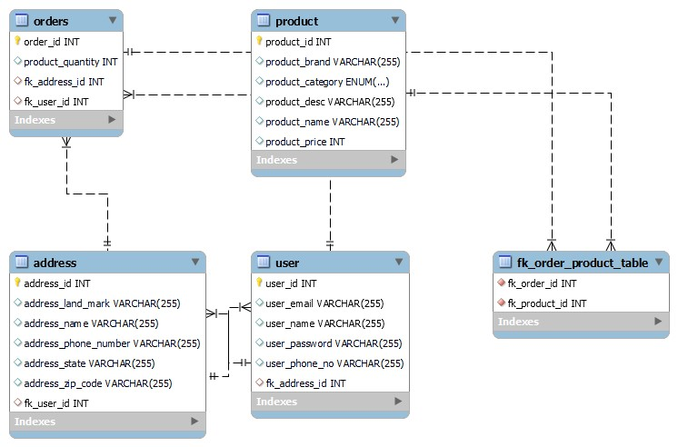

**Batch Code:ANPC-6058**

**Student Id:AF0330643**

**Project Name:E- Commerce Application**